

**UNIVERSIDAD DE LAS FUERZAS ARMADAS**

**COMPUTER SCIENCE DEPARTMENT**

**Object-Oriented Programming**

**Team:** TIC Solutions

**Members:** Chicango George

Constante Erika

Córdova Xavier

Cuichan Kevin

**NRC:** 3248 **Teacher:** Edison Lascano

**Date:** 06-12-2020

**Requirements specification**

**Use Cases Diagram**

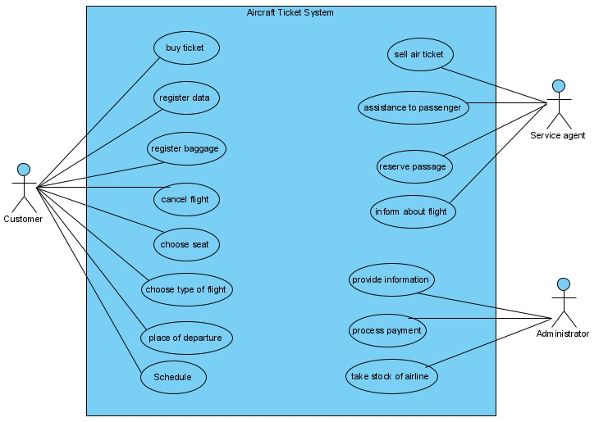

**User characteristics**

|  |  |
| --- | --- |
| **Type of user** | Customer |
| **Formation** | Person who will acquire the service |
| **Activities** | Buy the service from the airline |

|  |  |
| --- | --- |
| **Type of user** | Service Agent |
| **Formation** | Customer Support |
| **Activities** | Help Customers |

|  |  |
| --- | --- |
| **Type of user** | Administrador |
| **Formation** | Administration |
| **Activities** | System control and management |

**Specific requirements**

|  |  |
| --- | --- |
| **Identification of the requirement:** | UC01 |
| **Requirement Name:** | Buy ticket |
| **Features:** | The customer will purchase the ticket |
| **Description of the requirement:** | The system will allow the customer to obtain the ticket that he bought |
| **Non-functional requirement:** | * NFR01 * NFR02 * NFR03 |
| **Requirement priority:**  **High** | |

|  |  |
| --- | --- |
| **Identification of the requirement:** | UC02 |
| **Requirement Name:** | Register data |
| **Features:** | Users must enter their data into the system |
| **Description of the requirement:** | The system allows you to enter the user's personal data when purchasing the ticket. |
| **Non-functional requirement:** | * NFR01 * NFR02 * NFR03 |
| **Requirement priority:**  high | |

|  |  |
| --- | --- |
| **Identification of the requirement:** | UC03 |
| **Requirement Name:** | Register baggage |
| **Features:** | Users must register the weight of their luggage in the system |
| **Description of the requirement:** | The system will allow the weight of luggage to be registered |
| **Non-functional requirement:** | * NFR01 * NFR02 * NFR03 |
| **Requirement priority:**  high | |

|  |  |
| --- | --- |
| **Identification of the requirement:** | UC04 |
| **Requirement Name:** | Cancel flight |
| **Features:** | Users must cancel the tickets purchased |
| **Description of the requirement:** | The system may allow the user to cancel the tickets previously purchased |
| **Non-functional requirement:** | * NFR01 * NFR02 * NFR03 |
| **Requirement priority:**  high | |

|  |  |
| --- | --- |
| **Identification of the requirement:** | UC05 |
| **Requirement Name:** | Choose seat |
| **Features:** | The system will allow users to choose seats |
| **Description of the requirement:** | allows user to choose seat (s) |
| **Non-functional requirement:** | * NFR01 * NFR02 * NFR03· |
| **Requirement priority:**  high | |

|  |  |
| --- | --- |
| **Identification of the requirement:** | UC06 |
| **Requirement Name:** | choose type of flight |
| **Features:** | The system will allow users to choose the type of class in which they will travel |
| **Description of the requirement:** | allows the user to choose the type of class in which they will travel |
| **Non-functional requirement:** | * NFR01 * NFR02 * NFR03· |
| **Requirement priority:**  high | |

|  |  |
| --- | --- |
| **Identification of the requirement:** | UC07 |
| **Requirement Name:** | place of departure |
| **Features:** | The system will allow the user to choose the place from where they want to depart the flight |
| **Description of the requirement:** | The user will choose from which airport they want to depart |
| **Non-functional requirement:** | * NFR01 * NFR02 * NFR03· |
| **Requirement priority:**  high | |

|  |  |
| --- | --- |
| **Identification of the requirement:** | UC08 |
| **Requirement Name:** | schedule |
| **Features:** | The system allows the user to choose the time they want their flight |
| **Description of the requirement:** | When the user determines the flight time, the available hours will be displayed |
| **Non-functional requirement:** | * NFR01 * NFR02 * NFR03· |
| **Requirement priority:**  high | |

|  |  |
| --- | --- |
| **Identification of the requirement:** | UC09 |
| **Requirement Name:** | sell air ticket |
| **Features:** | The system allows the customer to sell one or more tickets |
| **Description of the requirement:** |  |
| **Non-functional requirement:** | * NFR01 * NFR02 * NFR03· |
| **Requirement priority:**  high | |

|  |  |
| --- | --- |
| **Identification of the requirement:** | UC12 |
| **Requirement Name:** | Inform about flight |
| **Features:** | The employee will give information about the flights |
| **Description of the requirement:** | The employee will provide information to the customers about their flights |
| **Non-functional requirement:** | * NFR01 * NFR02 * NFR03 |
| **Requirement priority:**  High | |

|  |  |
| --- | --- |
| **Identification of the requirement:** | **UC13** |
| **Requirement Name:** | Provide Information |
| **Features:** | The administrator will help the clients |
| **Description of the requirement:** | The administrator will help clients by giving them information on how to use the system properly. |
| **Non-functional requirement:** | * NFR01 * NFR02 * NFR03 |
| **Requirement priority:**  **High** | |

|  |  |
| --- | --- |
| **Identification of the requirement:** | UC14 |
| **Requirement Name:** | Process payment |
| **Features:** | The Administrator will receive the money from the customers |
| **Description of the requirement:** | The administrator will be in charge of making the respective charges to customers |
| **Requirement priority:**  High | |

|  |  |
| --- | --- |
| **Identification of the requirement:** | UC15 |
| **Requirement Name:** | Take stock of airline |
| **Features:** | The administrator will generate the final balance |
| **Description of the requirement:** | The administrator will generate the annual or weekly balance of the airline's earnings |
| **Non-functional requirement:** | * NFR01 * NFR02 * NFR03 |
| **Requirement priority:**  High | |

**Non-functional requirements**

|  |  |
| --- | --- |
| **Identification of the requirement:** | NFR01 |
| **Requirement Name:** | System interface. |
| **Features:** | The system will present a simple user interface to make it easy for users of the system to use. |
| **Description of the requirement:** | The system must have an intuitive and simple user interface. |
| **Requirement priority:**  high | |

|  |  |
| --- | --- |
| **Identification of the requirement:** | NFR02 |
| **Requirement Name:** | Information security |
| **Features:** | The system guarantees users security regarding the information that is proceeded in the system. |
| **Description of the requirement:** | Guarantee the security of the system with respect to the information and data that are handled such as documents, files and passwords. |
| **Requirement priority:**  high | |

|  |  |
| --- | --- |
| **Identification of the requirement:** | NFR03 |
| **Requirement Name:** | Performance |
| **Features:** | The system will guarantee users performance in terms of data stored in the system, offering reliability to it. |
| **Non-functional requirement:** | Guarantee the performance of the computer system to the different users. In this sense, the information stored or records made may be consulted and updated permanently and simultaneously, without affecting the response time**.** |
| **Requirement priority:**  High | |

|  |  |
| --- | --- |
| **Identification of the requirement:** | NFR04 |
| **Requirement Name:** | Maintenance. |
| **Features:** | The system must have an installation manual and user manual to facilitate the maintenance that will be carried out by the administrator. |
| **Non-functional requirement:** | The system must have easily updateable documentation that allows maintenance operations to be carried out with the least possible effort. |
| **Requirement priority:**  High | |